"Hospital vs. Country Club"
07.25.2010 A.M.

I. How To Be Right With God

God created us to be with Him.
Our sin separated us from God.
Sins cannot be removed by good deeds.
Paying the price for sin, Jesus died & rose again.
Everyone who trusts in Him alone has eternal life.
Life with Jesus starts now & last forever.

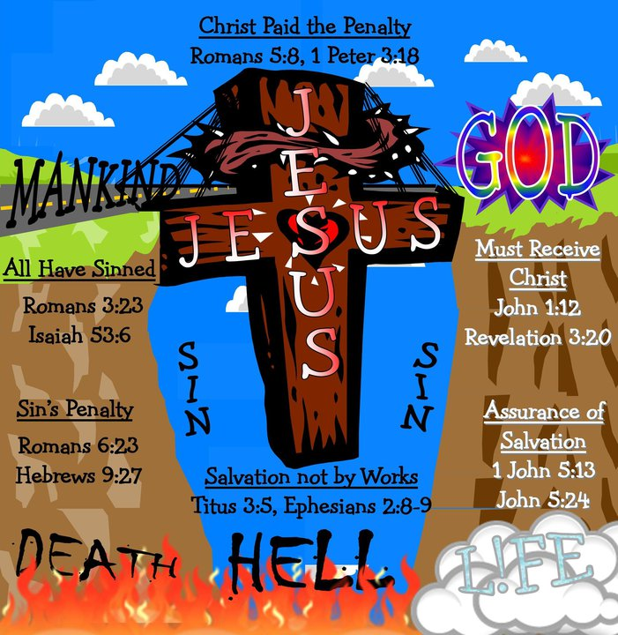
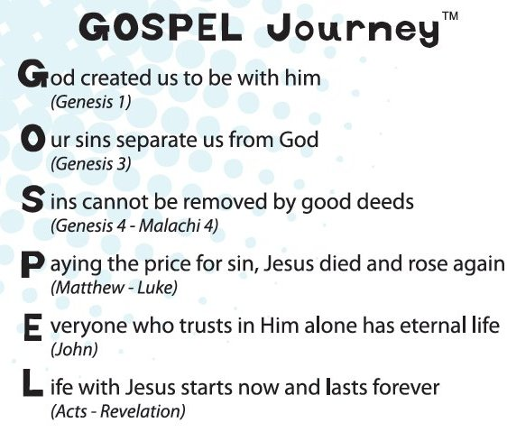

"Dear Jesus...Thank you so much for loving me even when I don't deserve You at all. Lord, come into my life, change me, break me, make me new, make me whole... forgive me. Purify my heart. Jesus I believe You died on the cross & rose again three days later. You are my Savior & one day I will live with You forever. But meanwhile, help me to stand for You. To shine for You, to make a difference & let Your truth be known. Use me Lord, Holy Spirit fill me. I love you so much! In Jesus' Name, Amen.
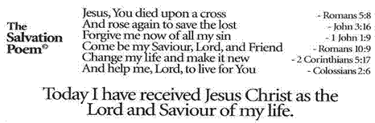

II. Mark 2:13-17 NKJV
“Those who are well have no need of a physician, but those who are sick. I did not come to call the righteous, but sinners, to repentance.” {Matthew 9:9-12 & Luke 5:27-31}

III. Should a church be more like a hospital, or a country club?

IV. Closing Video: “What Now?” {2 minutes}
After the video our service will have concluded but, our mission has just begun.

